Summer Street Industries Receives Close To $3 Million From Federal And Provincial Governments For A New Greenhouse Expansion
This entry was posted in News on May 23, 2023.
New Glasgow’s Summer Street Industries is receiving almost $3 million from the federal and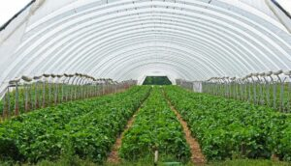 provincial governments towards a new greenhouse expansion. The funding will be used to construct a three-bay, all season, fully accessible greenhouse at Summer Street Industries. It will provide hands-on gardening skills, on-site programing, and space for local businesses to lease and grow food.
Central Nova MP and Immigration Minister Sean Fraser says the federal government will invest $1.5 million toward the fully accessible all-season greenhouse. Pictou West MLA and Community Services Minister Karla MacFarlane and Agriculture Minister and Guysborough-Tracadie MLA Greg Morrow confirmed the province will provide $1.4 million to the project.
MacFarlane says the expansion will allow people living with intellectual disabilities to find fulfilling work, while providing the area with locally grown, healthy food.
Food grown through this project will be used for Summer Street’s food-service business, help supply local food banks and be sold locally.
The social enterprise provides opportunities and employment to more than 200 adults with intellectual disabilities.

